[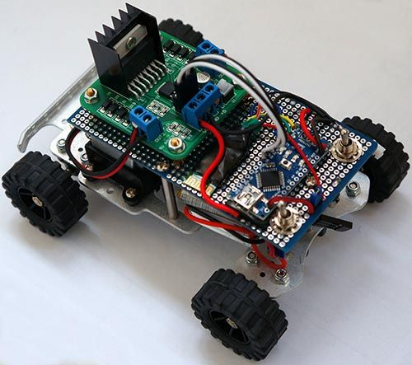](http://www.instructables.com/file/FTI1G39HCB8TBKX/)

This is a simple project of Android Bluetooth Car with Bluetooth control. Arduino controller is used

To control the car used Android-device with a built-in accelerometer. Tilt forward - car goes forward, tilt to the left - car turns to the left, tilt back - car goes back. Speed of movement or rotation depends on how much you tilt the device. Sensitivity and value of the tilt set in the configuration Android-apps. Also are provided a normal way to control: the buttons on the screen. In addition to all I implemented the touch control. Total 3 ways to control the RC Car.

Capabilities of the device you can see on the video above

**Step 1: Android Device**

[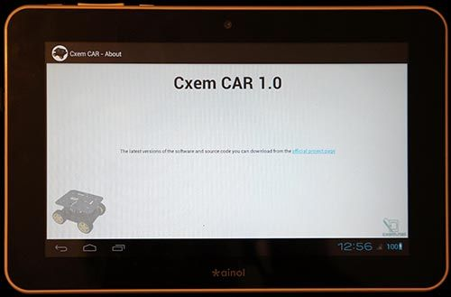](http://www.instructables.com/file/FVLNTAZHCB8TBBE/)

**Parts needed**

**1. Android device**

The most important part - Android device with accelerometer and Bluetooth: tablet, smartphone and other... As an Android device, I used a cheap Chinese tablet "Ainol Aurora" with an external USB-Bluetooth module (because its not have own), connected via USB Host.

**Step 2: DIY Car Chassis**

[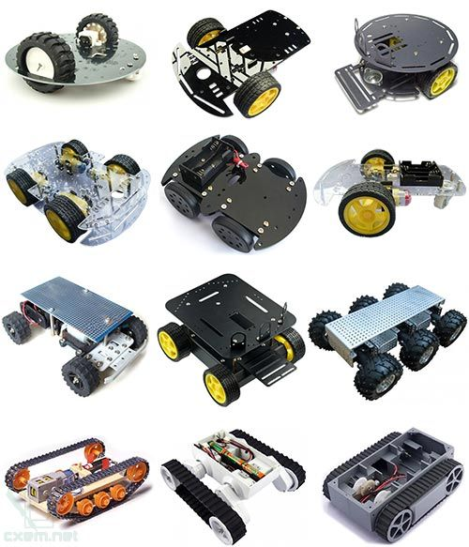](http://www.instructables.com/file/F0GXNDDHCB8TBBF/)

**2. DIY Car Chassis**

We also need any chassis with 2 or 4 DC motors. You can use an old RC toy car. As a platform I used a small RC DIY platform, bought [on AliExpress for 25$](http://goo.gl/Zfw0BP). It's most suitable track chassis for this project.

**Step 3: Controller (MCU)**

[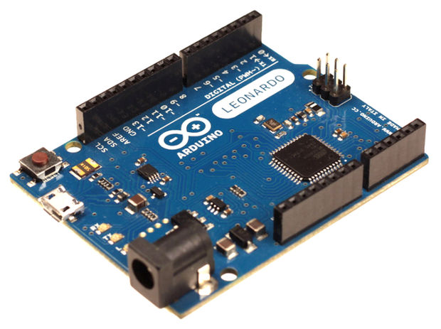](http://www.instructables.com/file/FXX2FOQHCB8TBGG/)

**3. Controller (MCU)**

You need any [Arduino-compatible controller](http://goo.gl/XYnT31) (Nano, Uno, Leonardo, Mini and other)

The controller should contain 2 PWM and UART.

**Step 4: Bluetooth Module**

[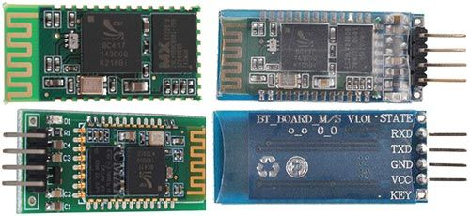](http://www.instructables.com/file/F4B3ISBHCB8TBBI/)

**4. Bluetooth module**

As a Bluetooth module uses cheap Chinese module Bluetooth Serial HC-06 ([3-4$ on AliExpress](http://goo.gl/Rmr7oG)). Instructions guide on connecting bluetooth module to Arduino is[here](http://solderer.tv/data-transfer-between-android-and-arduino-via-bluetooth/).  
You can use HC-05, HC-07 and other serial Bluetooth modules

**Step 5: Motor Driver**

[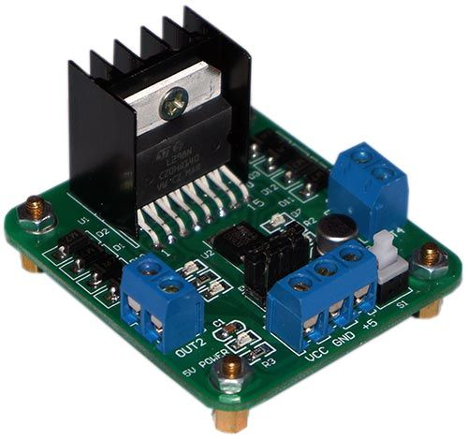](http://www.instructables.com/file/F8HLKKVHCB8TBBJ/)

**5. Motor Driver**

I used L298N Dual Bridge DC stepper Motor Driver module. It cost [3-5$ on AliExpress](http://goo.gl/EQcuZB).

**Step 6: Other Parts**

[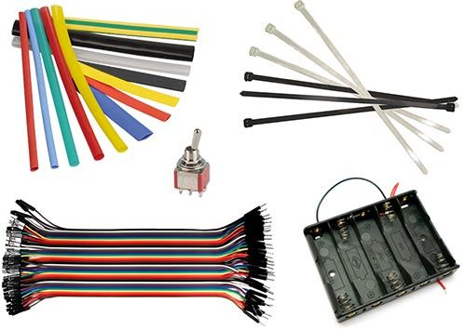](http://www.instructables.com/file/FAB85ZYHCB8TBBK/)

**6. Other parts**

**Step 7: Theory**

[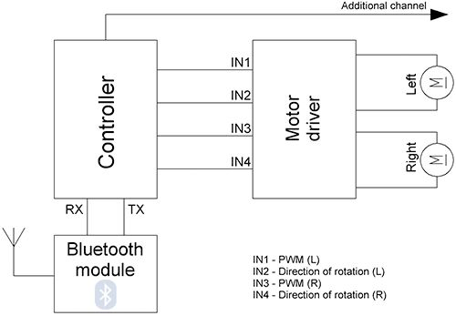](http://www.instructables.com/file/FXL2E8OHCB8TBHL/)

**Theory**

All calculations are performed in the Android-application, and immediately calculate the values 2‹2‹of the PWM for the left and right motor. Application has flexible settings, such as the range of the PWM, the sensitivity of tilt, the minimum threshold for the PWM and other. Example commands transmitted by Bluetooth:  
L-255\rR-120\r  
L - the command to the left engine, R - for the right  
A dash means the motor rotation to move back  
255 - PWM value (for Arduino is the maximum speed of rotation)  
\r - end of command.  
On this command RC car will move forward and slightly rotated to the right, as right engine rotates slowly left.

L255\rR-255\r  
On this command the left engine will rotate back and forward right, forcing a car to rotate around its axis counterclockwise.

H1\r  
Command is an additional channel to which you can connect for example lights, sound, etc.

Symbols command L, R and H can be defined in the settings of Android-applications.

In the MCU control program provides a timer that shuts off the engine if the last command was received more than n-seconds ago. The data are stored in the EEPROM memory of the controller and can be changed from Android device. The range of this setting is from 0.1 seconds to 99.9 seconds. This setting can be disabled. To work with EEPROM provides commands: Fr - reading values 2‹2‹and Fw - record values.

**Electronics**

Block diagram see on picture above

**Step 8: Android Application**

[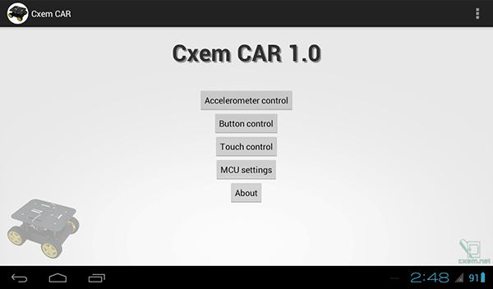](http://www.instructables.com/file/FCCZ6L5HCB8TBIG/)

As we can see, the Arduino connects to Bluetooth module and a motor driver with two or four connected motors.

**Android Application**

The application for Android was written in Eclipse IDE. All sources of the project and the project for Eclipse, you can download below. Android version on your device must be > 3.0.

The application contains several activity. Main activity is a home screen with buttons running different operating modes and settings

There are 3 control modes Bluetooth-car: from accelerometer, screen buttons and touch-control.

**Android application settings**

Screenshot of settings CxemCar Android application version 1.0

**MAC address**

To establish a connection with the RC Car's Bluetooth module, you must set MAC-address in the application settings. But first, you must configure the pair the devices on Android-device: open Settings -> Bluetooth and click "Search for devices". When the phone finds our Bluetooth-module, click them and enter password for pairing (usually "1234")

To know Bluetooth module MAC-address possible from any application, such as[Bluetooth Terminal](https://play.google.com/store/apps/details?id=Qwerty.BluetoothTerminal). To do this, click "Connect a device - Secure" and in the resulting window, click the button "Scan for devices". Software will be scans the Bluetooth devices and displays them MAC-address.

**Step 9: Arduino RC Car Wiring**

[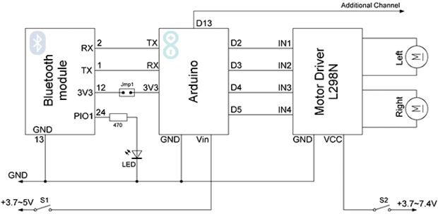](http://www.instructables.com/file/F0R8XD3HCB8TBJ8/)

**Wiring diagram for Arduino controller**

In the circuit I used a jumper (in the scheme Jmp1), because with a connected Bluetooth module is impossible be load sketch to the Arduino.

I soldered a Bluetooth-module to the Arduino and led status light. For communication between Arduino and Bluetooth, read this article: Arduino and Bluetooth. Module HC-06 placed in heat-shrink tube 10mm. Bluetooth-state LED with current limiting resistor ([calculator](http://english.cxem.net/calc/ledcalc.php)) were also placed in heat-shrink tube.

In the breadboard platform, I drilled a hole and secure motor driver L298N. Arduino board attached with double-sided tape

Between the car platform and breadboard I placed 3 Li-Po battery 3.7V 1100 mAh. Power to the controller and motors separately: Arduino powered by a 3.7 V battery, and the motors and driver L298N from two 3.7V batteries connected in series. There are two 2-position power switch - one position is the power from the batteries to consumers, in the other position to charging terminals.

Beetween BT pin RX (2) and Arduino pin TX may require level shifter. For this, you can use voltage divider: [calculator 5V to 3.3V](http://english.cxem.net/calc/divider_calc.php?u1=5&r1=1000&r2=2000&type=1)

**Step 10: Software**

[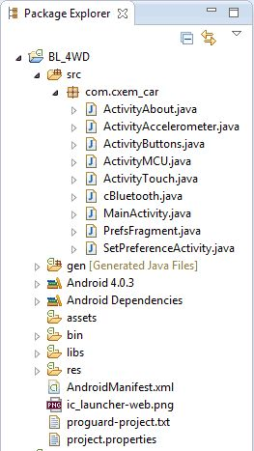](http://www.instructables.com/file/FHDS4PLHCB8U4XG/)

The program was written in Arduino IDE 1.01.

#include "EEPROM.h"

#define D1 2 // direction of motor rotation 1  
#define M1 3 // PWM left motor  
#define D2 4 // direction of motor rotation 2  
#define M2 5 // PWM right motor  
#define HORN 13 // additional channel 1  
//#define autoOFF 2500 // milliseconds after which the robot stops when the connection

#define cmdL 'L' // UART-command for left motor  
#define cmdR 'R' // UART-command for right motor  
#define cmdH 'H' // UART-command for additional channel (for example Horn)  
#define cmdF 'F' // UART-command for EEPROM operation  
#define cmdr 'r' // UART-command for EEPROM operation (read)  
#define cmdw 'w' // UART-command for EEPROM operation (write)

char incomingByte; // incoming data

char L_Data[4]; // array data for left motor  
byte L_index = 0; // index of array L  
char R_Data[4]; // array data for right motor  
byte R_index = 0; // index of array R  
char H_Data[1]; // array data for additional channel  
byte H_index = 0; // index of array H  
char F_Data[8]; // array data for EEPROM  
byte F_index = 0; // index of array F  
char command; // command

unsigned long currentTime, lastTimeCommand, autoOFF;

void setup() {  
Serial.begin(9600); // initialization UART  
pinMode(HORN, OUTPUT); // additional channel  
pinMode(D1, OUTPUT); // output for motor rotation  
pinMode(D2, OUTPUT); // output for motor rotation  
/*EEPROM.write(0,255);  
EEPROM.write(1,255);  
EEPROM.write(2,255);  
EEPROM.write(3,255);*/  
timer_init(); // initialization software timer  
}

void timer_init() {  
uint8_t sw_autoOFF = EEPROM.read(0); // read EEPROM "is activated or not stopping the car when losing connection"  
if(sw_autoOFF == '1'){ // if activated  
char var_Data[3];  
var_Data[0] = EEPROM.read(1);  
var_Data[1] = EEPROM.read(2);  
var_Data[2] = EEPROM.read(3);  
autoOFF = atoi(var_Data)*100; // variable autoOFF ms  
}  
else if(sw_autoOFF == '0'){   
autoOFF = 999999;  
}  
else if(sw_autoOFF == 255){  
autoOFF = 2500; // if the EEPROM is blank, dafault value is 2.5 sec  
}  
currentTime = millis(); // read the time elapsed since application start  
}

void loop() {  
if (Serial.available() > 0) { // if received UART data  
incomingByte = Serial.read(); // raed byte  
if(incomingByte == cmdL) { // if received data for left motor L  
command = cmdL; // current command  
memset(L_Data,0,sizeof(L_Data)); // clear array  
L_index = 0; // resetting array index  
}  
else if(incomingByte == cmdR) { // if received data for left motor R  
command = cmdR;  
memset(R_Data,0,sizeof(R_Data));  
R_index = 0;  
}  
else if(incomingByte == cmdH) { // if received data for additional channel  
command = cmdH;  
memset(H_Data,0,sizeof(H_Data));  
H_index = 0;  
}   
else if(incomingByte == cmdF) { // if received data for EEPROM op  
command = cmdF;  
memset(F_Data,0,sizeof(F_Data));  
F_index = 0;  
}  
else if(incomingByte == '\r') command = 'e'; // end of line  
else if(incomingByte == '\t') command = 't'; // end of line for EEPROM op

if(command == cmdL && incomingByte != cmdL){  
L_Data[L_index] = incomingByte; // store each byte in the array  
L_index++; // increment array index  
}  
else if(command == cmdR && incomingByte != cmdR){  
R_Data[R_index] = incomingByte;  
R_index++;  
}  
else if(command == cmdH && incomingByte != cmdH){  
H_Data[H_index] = incomingByte;  
H_index++;  
}   
else if(command == cmdF && incomingByte != cmdF){  
F_Data[F_index] = incomingByte;  
F_index++;  
}   
else if(command == 'e'){ // if we take the line end  
Control4WD(atoi(L_Data),atoi(R_Data),atoi(H_Data));  
delay(10);  
}  
else if(command == 't'){ // if we take the EEPROM line end  
Flash_Op(F_Data[0],F_Data[1],F_Data[2],F_Data[3],F_Data[4]);  
}  
lastTimeCommand = millis(); // read the time elapsed since application start  
}  
if(millis() >= (lastTimeCommand + autoOFF)){ // compare the current timer with variable lastTimeCommand + autoOFF  
Control4WD(0,0,0); // stop the car  
}  
}

void Control4WD(int mLeft, int mRight, uint8_t Horn){

bool directionL, directionR; // direction of motor rotation L298N  
byte valueL, valueR; // PWM M1, M2 (0-255)

if(mLeft > 0){  
valueL = mLeft;  
directionL = 0;  
}  
else if(mLeft < 0){  
valueL = 255 - abs(mLeft);  
directionL = 1;  
}  
else {  
directionL = 0;  
valueL = 0;  
}

if(mRight > 0){  
valueR = mRight;  
directionR = 0;  
}  
else if(mRight < 0){  
valueR = 255 - abs(mRight);  
directionR = 1;  
}  
else {  
directionR = 0;  
valueR = 0;  
}

analogWrite(M1, valueL); // set speed for left motor  
analogWrite(M2, valueR); // set speed for right motor  
digitalWrite(D1, directionL); // set direction of left motor rotation  
digitalWrite(D2, directionR); // set direction of right motor rotation

digitalWrite(HORN, Horn); // additional channel  
}

void Flash_Op(char FCMD, uint8_t z1, uint8_t z2, uint8_t z3, uint8_t z4){

if(FCMD == cmdr){ // if EEPROM data read command  
Serial.print("FData:"); // send EEPROM data  
Serial.write(EEPROM.read(0)); // read value from the memory with 0 address and print it to UART  
Serial.write(EEPROM.read(1));  
Serial.write(EEPROM.read(2));  
Serial.write(EEPROM.read(3));  
Serial.print("\r\n"); // mark the end of the transmission of data EEPROM  
}  
else if(FCMD == cmdw){ // if EEPROM data write command  
EEPROM.write(0,z1); // z1 record to a memory with 0 address  
EEPROM.write(1,z2);  
EEPROM.write(2,z3);  
EEPROM.write(3,z4);  
timer_init(); // reinitialize the timer  
Serial.print("FWOK\r\n"); // send a message that the data is successfully written to EEPROM  
}

The code uses a library to work with EEPROM AVR-memory. Arduino board by USART from the Bluetooth module receives data ready for the left and right engine. All basic calculations are performed in the Android application.

The project structure in Eclipse you can see on the screenshot above.

You can download the source code for the Arduino, and the project for Eclipse  
[Download](http://solderer.tv/wp-content/uploads/2013/04/BL_4WD_1_3.apk)APK application for Android-device

The latest software version can be found [on this page](http://solderer.tv/cxemcar/)Video of demonstration the virtual steering wheel mode (1.2 version and above):